***List of Executed commands.***

1. Create user with name Techie and provide sudo access to user.

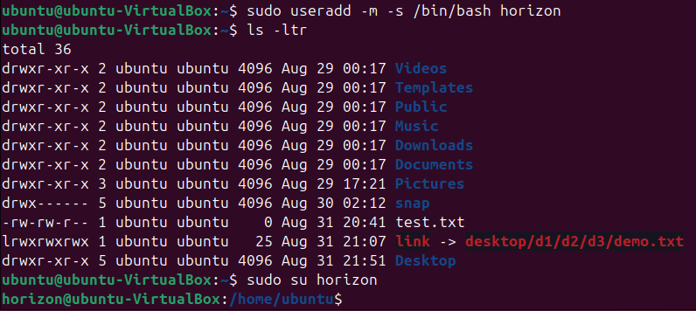

* Sudo -m -s /bin/bash horizon : to create a new user.
* m → Creates a home directory (/home/newusername)
* - s /bin/bash → Sets the default shell to Bash
* New username → Replace with your desired username

1. Navigate to the home directory.



* Cd ~ : To navigate to home directory

1. Create a new directory.



* mkdir : create a new directory.

1. List the contents of a directory.

* ls: to list the content of directory.

1. Change the current directory.



* cd : change directory.

1. Create a new empty file



* touch “ file name” : to create a empty file.

1. View the contents of a file

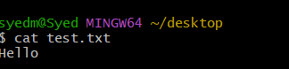

* cat : to view contents of a file.

1. Copy a file to another location

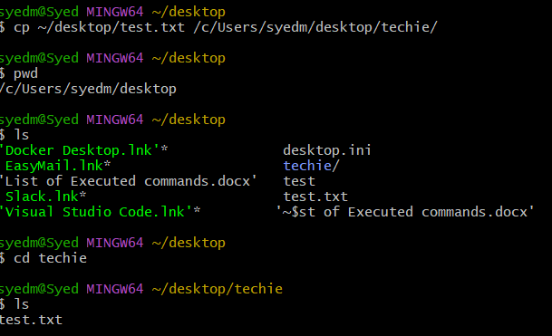

1. Move a file to another location

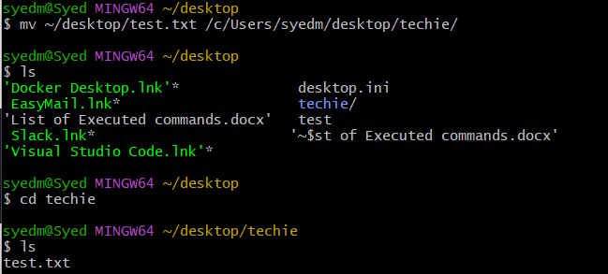

1. Rename a file

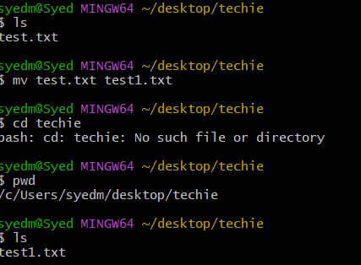

1. Delete a file.

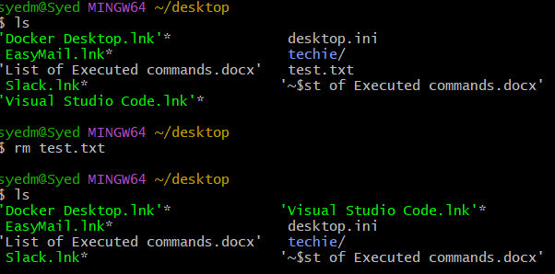

* rm – to delete the file

1. Grant or revoke permissions on a file or directory.



* **chmod –** generate or revoke permissions.

1. View the current date and time.



* **date :**  to know date and time

1. Check the system uptime.

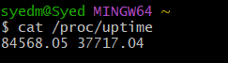

1. View the running processes.

* **ps -ef :** to know the system running process.

1. Kill a running process.

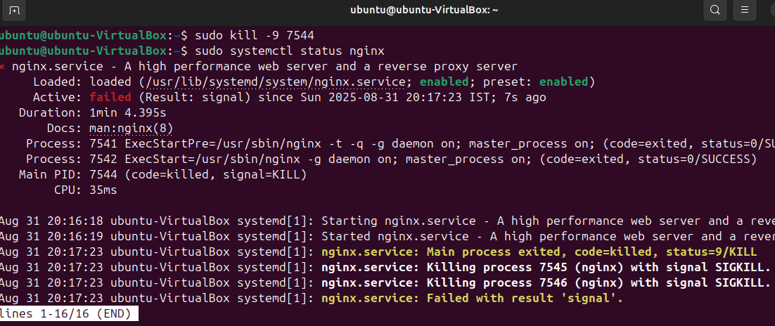

* **sudo kill -9 “process name” :** Kill a running process.

1. Install a package using the package manager (e.g., apt or yum).

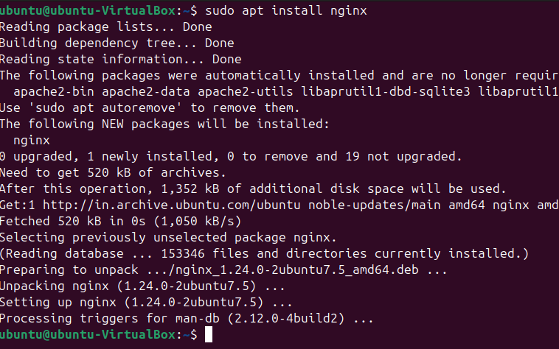

* **sudo apt install nginx:** Install a package using the package manager (e.g., apt or yum).

1. Update the system packages.

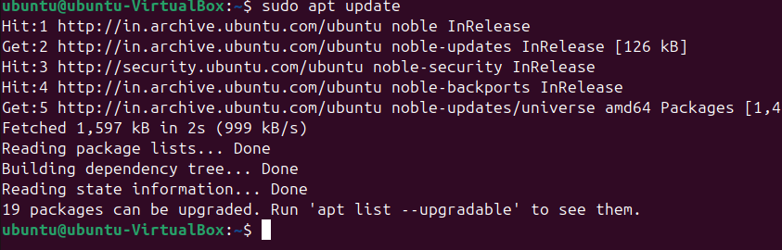

* **sudo apt update:** Update the system packages

1. Create a symbolic link.

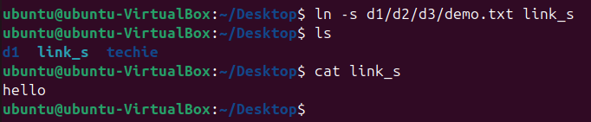

* Ln -s :Create a symbolic link.

1. Search for files using the find command.

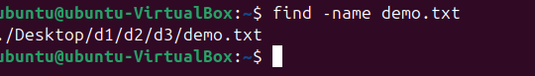

* find -name demo.txt - Search for files using the find command.

1. Compress and decompress files using tar.

* To Compress Files

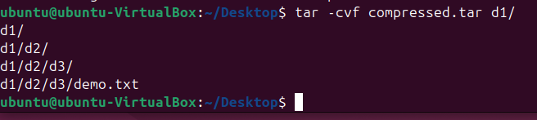

* To decompress files

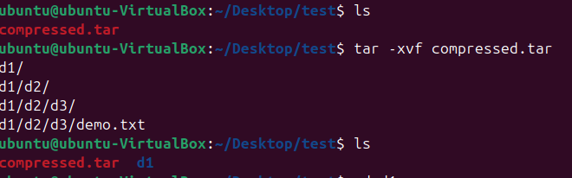

1. Monitor system resources with top or htop.

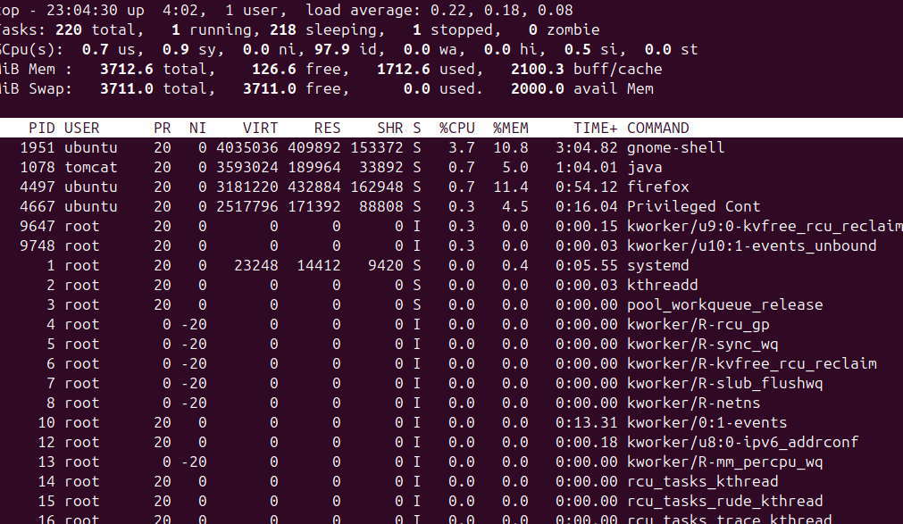

1. Create and manage user groups.

* Sudo addgroup groupname – to add a user group
* Sudo usermod -aG group name user name – to add an existing user to group
* groups user name– vie to which group it belongs to

1. Set up SSH password less authentication.

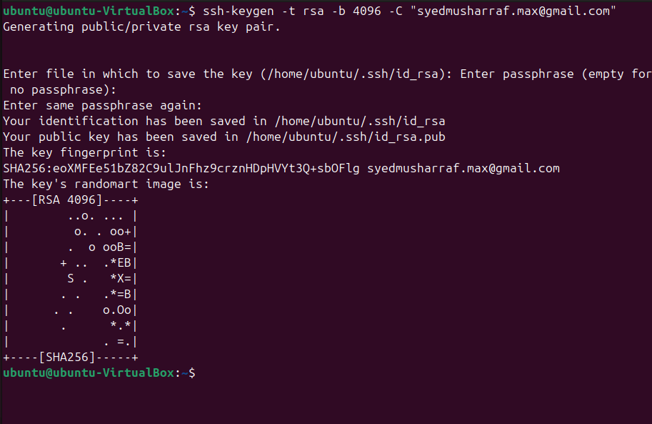

* Set up SSH password less authentication. - ssh-keygen -t rsa -b 4096 -C “[your_email@example.com](mailto:your_email@example.com)”

1. Monitor log files using tail or grep.

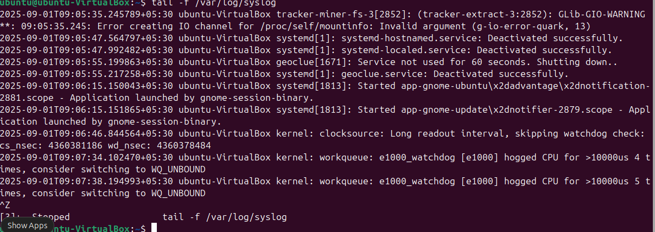

* Tail -f /var/log/syslog : to view the system service running

1. Set up a web server (e.g., Apache or Nginx).

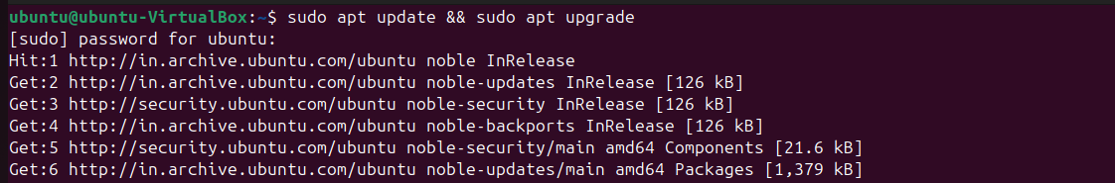

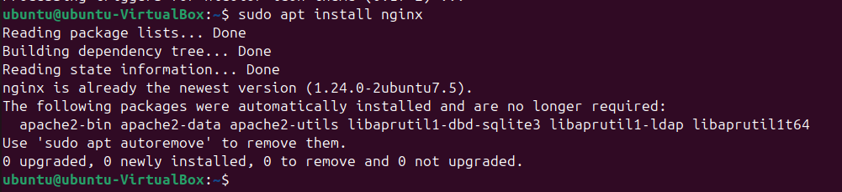

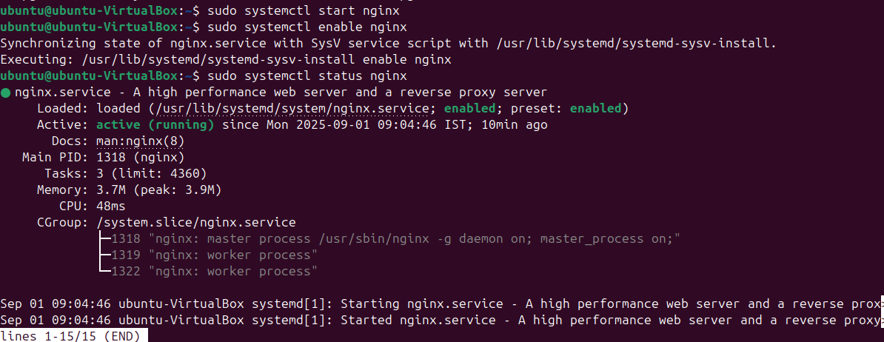

* **Sudo apt install nginx –** to install nginx service
* **Sudo apt start nginx –**  to start nginx service.

1. Configure and secure a MySQL Database.

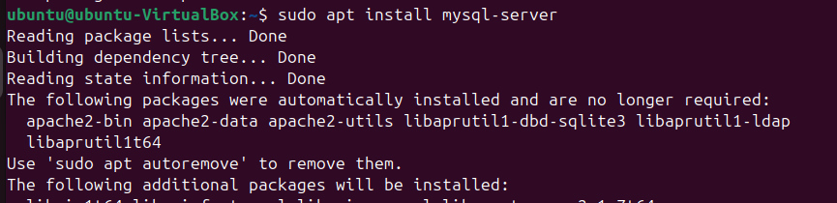



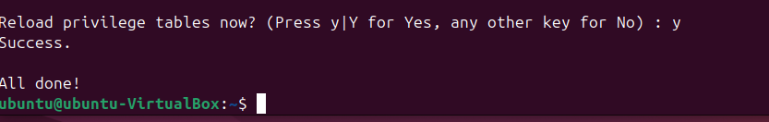

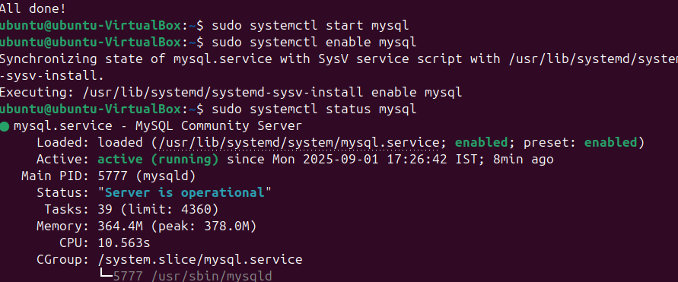

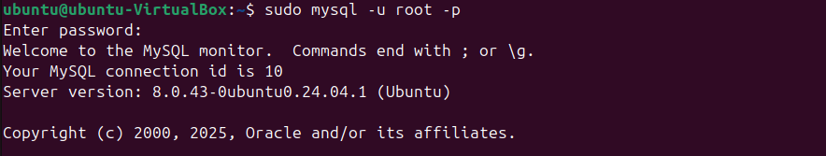

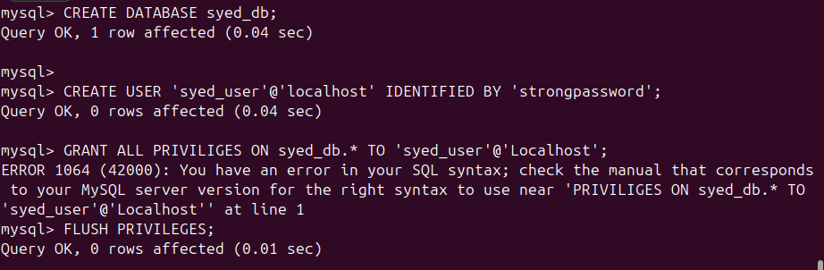



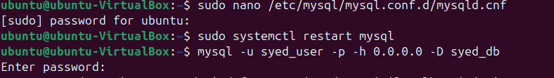

* Sudo apt install mysql-sever – This installs the MySQL server and client tools
* sudo mysql_secure_installation : Run the built-in security script:
* You’ll be prompted to:
* Set root password
* Remove anonymous users
* Disallow remote root login
* sudo systemctl start mysql : start mysql server
* -sudo systemctl enable mysql : enable the server
* Log In to MySQL : sudo mysql -u root -p

1. Set up a Application Server (e.g.,Apache Tomcat)

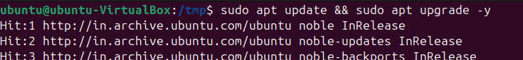

1. create a service file for Apache Tomcat.(Should execute by using systemtctl command)
2. Print specific columns from a delimited file.

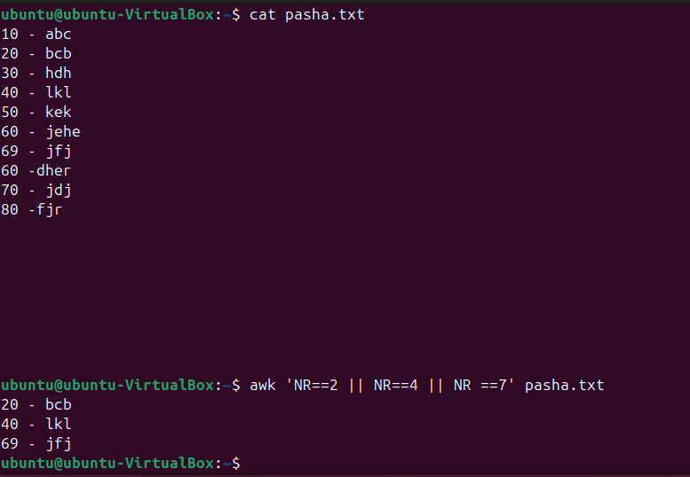

* awk 'NR==2 || NR==4 || NR==7' filename.txt

1. Filter and print lines based on a specific pattern or condition.

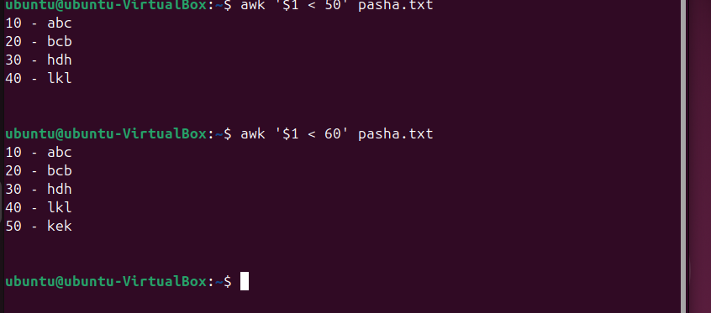

* awk '$1 > 100' filename

1. Calculate and print the average, sum, or other statistics of a column.

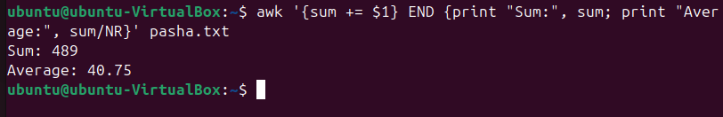

* awk '{sum += $2} END {print "Sum:", sum; print "Average:", sum/NR}' filename

1. Perform string manipulation, such as extracting substrings or changing case.



* str="UbuntuTomcat"
* echo ${str:6} # Output: Tomcat (from index 6 to end)
* echo ${str:0:6} # Output: Ubuntu (first 6 characters)

1. Count the occurrences of a specific pattern in a file.

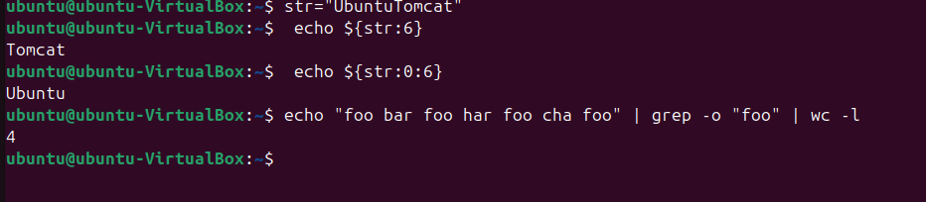

* -o prints each match on a new line.
* wc -l counts those lines = total matches.

1. Sort lines based on a specific field or column.

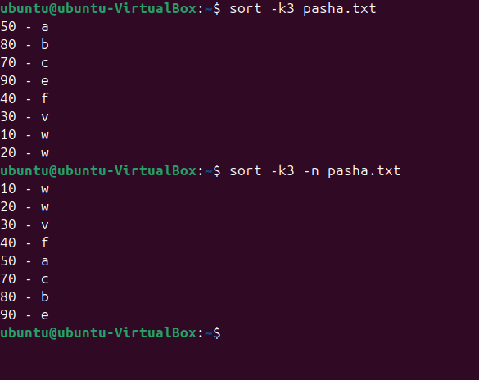

* sort -k2 -n filename
* sorts by column 2 numerically.
* Use -n to treat values as numbers.

1. Merge multiple files based on a common field or column.

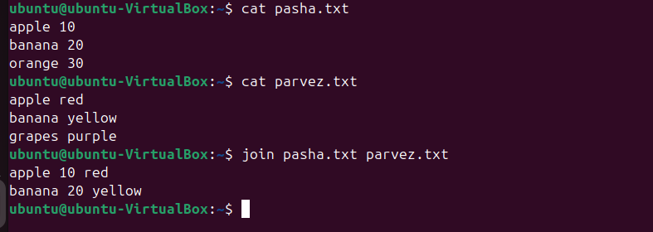

1. Substitute text in a file using search and replace.

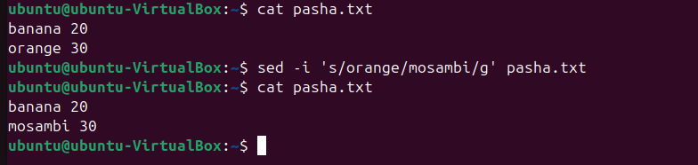

1. Delete specific lines based on a pattern or line number.



1. Append or insert text before or after a specific pattern or line.

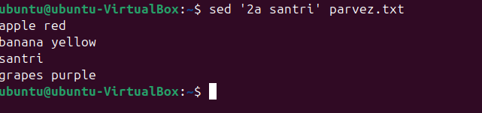

* Append or insert text before or after a specific pattern or line.
* sed 'Na TEXT_TO_APPEND' filename.txt
* Replace N with the line number and TEXT_TO_APPEND with the desired text. Insert before a specific line number.

1. Print only specific lines from a file.

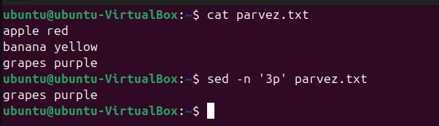

* sed -n '2p' filename.txt

1. Copy file from linux to windows machine.



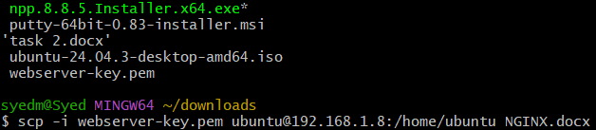

1. 5 use cases for AWK

* Extract specific column

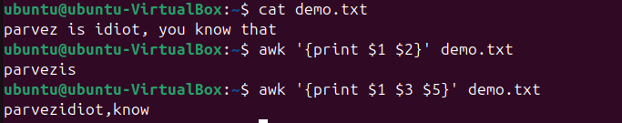

* Filter lines by pattern



* Summing values in a column

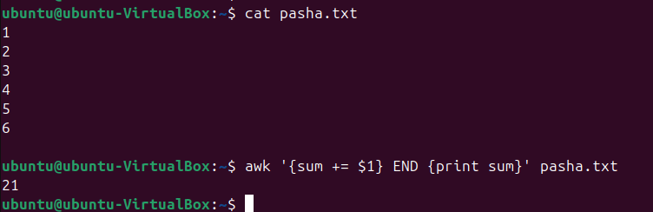

* Conditional formatting

